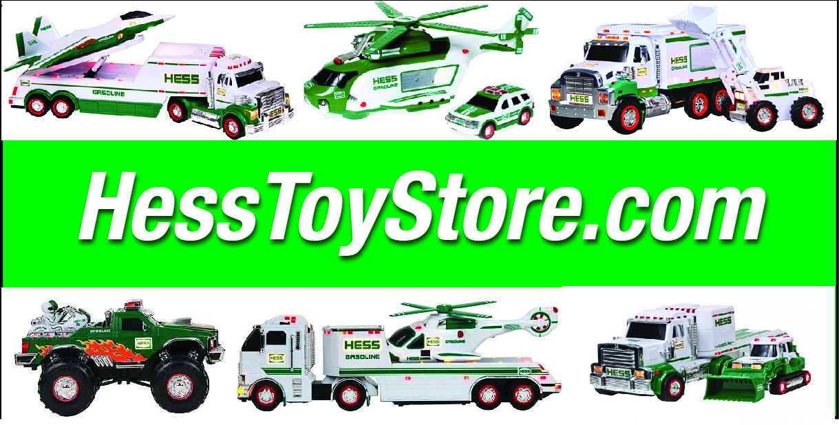
Hess Toy Store
Order Form

First & Last Name: _____________________________________________ Date: _____________________
Address: ____________________________________________________________________________________
City: ________________________________________ State: __________________ Zip: _________________
Cell: ________________________________________ Email: ________________________________________
Method of Payment: __ Check (please allow 2 weeks to clear
__ Bank Cashiers Check or Postal Money Order
What toys would you like to order?
SKU # Item Name / Description Unit Price Quantity Amount
________ ___________________________________ _____________ _________ $ ___________
________ ___________________________________ _____________ _________ $ ___________
________ ___________________________________ _____________ _________ $ ___________
________ ___________________________________ _____________ _________ $ ___________
________ ___________________________________ _____________ _________ $ ___________
________ ___________________________________ _____________ _________ $ ___________
Shipping ($12.95 per truck unless other indicated) $ ___________
TOTAL Enclosed: $ ____________________
Mail your order and payment to:
Hess Toy Store, Airpark Station, Box 12275, Scottsdale, AZ 85267
Or, scan and email to: Jackie@HessToyStore.com
TEL 480 513 0529 • Or FAX 260 600 6489

Special instructions: (Gift wrapping / card message?)
Send to a different address as a gift, etc.

Thank you for your order.

HessToyStore.com
Hess Toy Store • Airpark Station, Box 12275 • Scottsdale, AZ 85267

